**N4IOA01 1-channel RS485 to 4-20MA module**

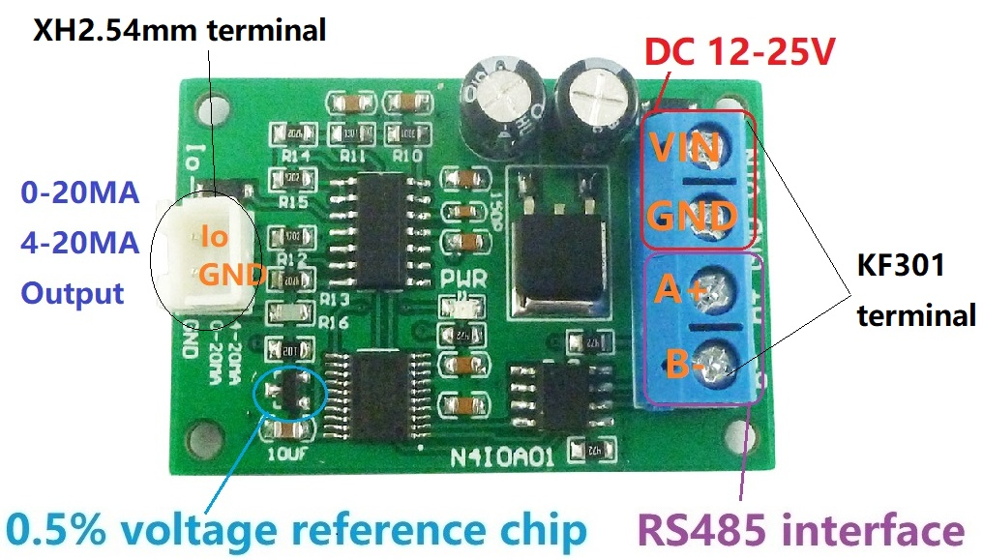**Features:**

1: Operating Voltage : DC 12 (DC 12-25V), recommended power supply with small ripple

2: Operating Current : 12-32MA(Related to the output current)

3: MODBUS RTU Command support 03 06 function code

4: The output current range is 0.50-21.00MA (for 4-20MA) and the maximum output current capability is 21MA.

5: Current resolution is 0.01MA, output accuracy is 1%; if the error is greater than 1%, it can be calibrated

6 :MODBUS commands can be made serial HyperTerminal (serial assistant) OR PLC Enter;

7 :Under the MODBUS command mode, it can support up to 247 devices in parallel

8: The current output terminal open circuit (no load) output voltage is 10V

9 :Size: 45 * 35 * 15mm

10 :Weight: 10g

Slave ID: Different "Sliver ID" can be set by command, the maximum number is 247

Under the MODBUS command mode,the slave ID must be correct

Modbus RTU Command Please refer to : " N4IOA01 modbus rtu protocol "

Command Description, Please refer to " N4AIA04 modbus rtu protocol "

**Wiring diagram:**

